**EXPT NO: 10 A python program to implement Dimensionality DATE: 04.11.2024 Reduction -PCA.**

# AIM:

TowriteapythonprogramtoimplementDimensionalityReduction-PCA.

# PROCEDURE:

ImplementingDimensionalityreduction-pcausingtheIrisdatasetinvolvethe following steps:

**Step1:ImportNecessaryLibraries**

First,importthelibrariesthatareessentialfordatamanipulation,visualization,and model building.

#Importingnecessarylibraries from sklearn import datasets

import pandas as pd

fromsklearn.preprocessingimportStandardScaler from sklearn.decomposition import PCA

import seaborn as sns

import matplotlib.pyplot as plt

**Step2:LoadtheIrisDataset**

TheIrisdatasetcanbeloadedanddisplaythefirstfewrowsofthedataset

# Load the Iris dataset iris=datasets.load_iris()

df = pd.DataFrame(iris['data'], columns=iris['feature_names'])

# Display the first few rows of the dataset

df.head()

# OUTPUT:

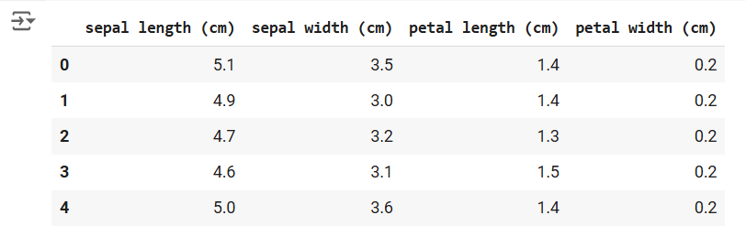

**Step3:Standardizethe data**

#StandardizethefeaturesusingStandardScaler scalar = StandardScaler()

scaled_data = pd.DataFrame(scalar.fit_transform(df)) #Scaling the data

#Displaythescaleddata(optional) scaled_data.head()

# OUTPUT:

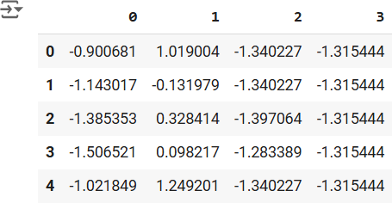

**Step4:ApplyPCA**

#ApplyPCAtoreducethedatato3components pca = PCA(n_components=3)

pca.fit(scaled_data) #Fit PCA on scaled data

data_pca = pca.transform(scaled_data) #Transformthedatatoprincipal components

# Convert PCA data to a DataFrame for easier inspection

data_pca=pd.DataFrame(data_pca,columns=['PC1','PC2','PC3']) data_pca.head()

# OUTPUT:

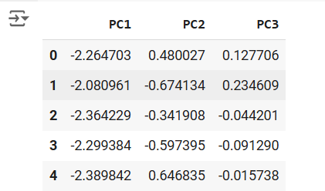

**Step5:ExplainedVarianceRatio**

#Calculatetheexplainedvarianceratioforeachprincipalcomponent explained_variance = pca.explained_variance_ratio_

print(f"ExplainedVariance Ratio: {explained_variance}")

# This output shows how much variance each principal component explains.

# OUTPUT:



**Step6:Visualizethereduceddata.**

#Plottingtheexplainedvarianceratioasascreeplot plt.figure(figsize=(8, 5))

plt.bar(range(1,len(explained_variance)+1),explained_variance,alpha=0.7, color='blue')

plt.ylabel('ExplainedVarianceRatio') plt.xlabel('Principal Components') plt.title('Scree Plot')

plt.show()

# OUTPUT:

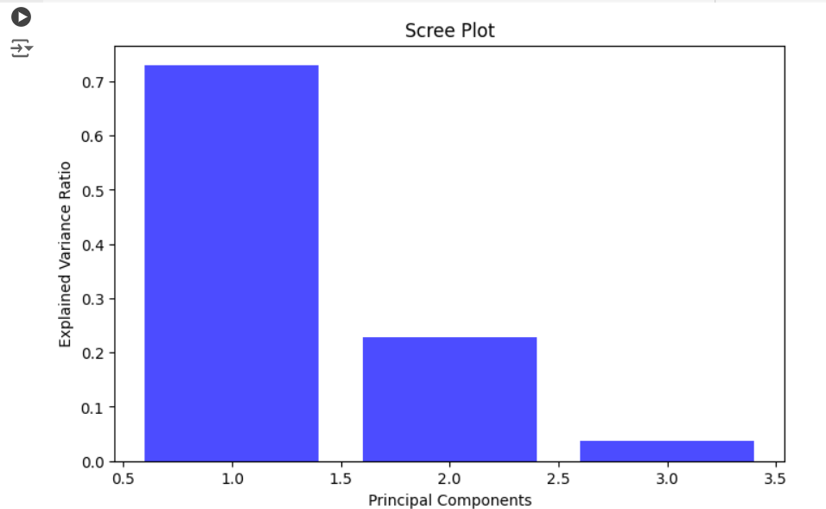

**RESULT:**

ThustheDimensionalityReductionhasbeenimplementedusingPCAinpython program Successfully.